**Statewide Transportation Planning Meeting**

**October 16, 2024**

**AGENDA**

**Facilitators: KYTC Planning**

**Location:** Ashland Train Depot, 99 15th Street, Ashland, KY

|  |  |  |
| --- | --- | --- |
| **Morning Sessions** | | |
| **8:45 a.m.**  **EDT** | Welcome to Ashland | **Joshua Blanton**  City of Ashland, Commissioner, Mayor Pro Tem |
| **8:55** | KYTC updates | **Mikael Pelfrey**  KYTC, Division of Planning, Director |
| **9:05** | FHWA updates | **Nick Vail**  FHWA-KY, Community Planner |
| **9:15** | Transportation Updates  District 9/KYOVA/FIVCO | **Steve Gunnell**  KYTC, District 9, Chief District Engineer  **Chris Chiles**  KYOVA, Executive Director  **Lance Hanshaw**  FIVCO, Executive Director |
| **9:45** | Break | |
| **9:55** | Planning/Design/Construction | **Stephen Sewell, PE, PTOE**  Palmer Engineering, Vice President |
| **10:40** | Group 1 – Walking Tour/Ashland Vision  Group 2 – Ashland Vision / Walking Tour | **Walking Tour**  **Stephen Sewell** Palmer Engineering, Vice President  **Blake Jones** KYTC District 9, Planning Supervisor  **Ashland Vision –**  **Michael Graese** City of Ashland, City Manager  **Steve Cole** City of Ashland, Director of Engineering |
| **12:00** | Lunch | |

**Announcements**

Upcoming STP Meetings (Tentative – subject to change):

* January 15, 2025 – Virtual Only
* April 16, 2025 – In Person
* July 16, 2025 – In Person/Virtual
* October 15, 2025 – In Person

**Personnel Updates**

**KYTC Central Office:**

**KYTC District Offices:**

Matthew Holder, KYTC, HSIP

Christopher Walden, KYTC, D-3 Planning

Chris James, KYTC, D12 TEBM Project Development

**FHWA-KY:**

Shundreka Givan, Division Administrator, FHWA

**ADDs:**

Ava Oljeski, Transportation Planner, LTADD

Charlie Allen, Urban Planning Engineer, LTADD

Jonathan Eldridge, Transportation Planner, GADD

Ethan Bates, Transportation Planner, BRADD

Aaron King, Transportation Planner, BSADD

**MPOs:**

Jake Zimmerer, MPO Coordinator, Radcliff-Elizabethtown Metropolitan Planning Organization

Mike Ziarnek, MPO Coordinator, Clarksville Metropolitan Planning Organization

**Afternoon Information**

HDO Meeting – Coordinate with Jason Blackburn

MPO Meeting – Coordinate with Thomas Witt

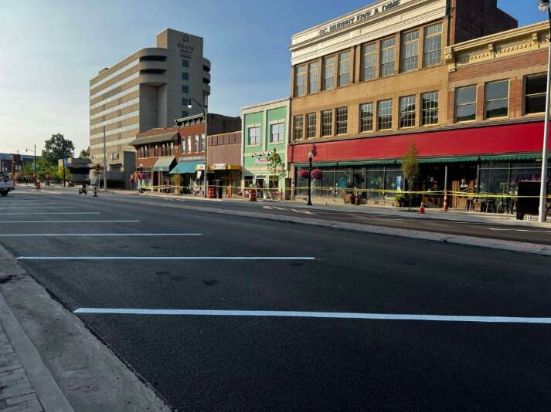

**Speaker Biographies**

**Joshua Blanton, Mayor Pro Tem, City of Ashland**

Josh Blanton was born in Ashland, attended college at Ohio University earning a bachelors and masters degrees, and has worked for 16 years in the steel and metals industry and currently works for Portable Solutions Group in Greenup County. Josh was the fourth generation of his family to work at the former Armco/AK Steel plant in Ashland. He was elected as City Commissioner in November 2020 and has served two terms, as well as serving as Mayor Pro Tem. Josh is also an adjunct instructor of Supply Chain Logistics at Marshall University. He proudly lives in Ashland with wife and two children.

**Mikael Pelfrey, Director of Planning, KYTC**

Mikael Pelfrey graduated with a B.S. in Civil Engineering from the University of Kentucky in May 2001. After working for consultants for five years, he started with KYTC in the Department of Rural and Municipal Aid in 2006. In May 2011, he moved to the Division of Planning and in November 2012 became the Strategic Corridor Team Lead, primarily overseeing consultant-led planning studies. In November 2018, he transitioned to become the Branch Manager for Modal Programs working with programs such as freight, bike/ped, air quality, and travel demand modeling and forecasting. A short stint as Assistant Director followed in December 2019, but since February 2020, he has been in an acting or permanent role as the Director of the Division of Planning.

He resides in Lexington with his wife Sagan, and sons Linden, Charleston, and Wells

**Nick Vail, Community Planner, FHWA**

Nick Vail has been a Community Planner for FHWA Kentucky Division since 2023. Prior to this role he worked eight years as a transportation planner for KIPDA in his hometown of Louisville, KY and eight years a transportation planner in the Dallas Forth Worth Area. Nick is a graduate of the University of Texas at Arlington with a Bachelors Degree in Interdisciplinary Studies and Masters Degree in Public Administration. In his free time Nick enjoys spending time with family, traveling, watching sports, and gardening.

**Steve Gunnell, Chief District Engineer, KYTC**

Steve is currently the Chief District Engineer for District 9.  He has worked in four different districts over his 28 year career with KYTC, mainly working in Construction and Maintenance.  He obtains a B.S. in Industrial Technology from Morehead State University and a B.S. in Civil Engineering form THE University of Kentucky.  He lives in West Liberty with his wife Leigh Ann and three sons: John, Mason, and Adam.

**Speaker Biographies**

**Chris Chiles, Executive Director, KYOVA**

Chris Chiles is the Executive Director of two agencies – KYOVA Interstate Planning Commission, and Region 2 Planning and Development Council. KYOVA is the Metropolitan Planning Organization for the Huntington, WV-KY-OH Urbanized Area, which includes Cabell and Wayne counties, West Virginia; Boyd and Greenup counties, Kentucky; and Lawrence County, Ohio. Region 2 is the Appalachian Regional Commission-designated Local Development District and U.S. Economic Development Administration-designated Economic Development District for southwestern West Virginia, serving the counties of Cabell, Lincoln, Logan, Mason, Mingo, and Wayne. Since being hired in 2016, Chris has placed an emphasis on community outreach, and sought to expand KYOVA and Region 2’s role as planning agencies for regional economic development and transportation initiatives through the cooperation and collaboration of government officials and stakeholders at all levels. Chris is a proud member of West Virginia Governor Jim Justice’s Complete Streets Advisory Board, serves as President of the Ohio Association of Regional Councils (OARC) and Development District Association of Appalachia (DDAA), serves as Treasurer of the West Virginia Association of Regional Councils (WVARC), and is an active member of the West Virginia Association of Metropolitan Planning Organizations (WVAMPO). Prior to joining KYOVA and Region 2, Chris worked for U.S. Senator Joe Manchin III. He is a graduate of Marshall University, where he obtained a Bachelor of Science in Chemistry and Master of Arts in Political Science. Chris has two daughters, Campbell (age 9) and Caroline (age 6).

**Lance Hanshaw, Executive Director, FIVCO**

Lance Hanshaw was born in Rowan County and raised in Olive Hill in Carter County, Lance Hanshaw brings a wealth of experience and a deep commitment to the FIVCO region. A graduate of Morehead State University with a bachelor's degree and Liberty University with a master's degree, Hanshaw has been a key figure in the Area Development Districts for nearly a decade. He began his tenure as FIVCO's Chief Financial Officer before moving to the Northern Kentucky Area Development District (NKADD), where he served as Director of Administration. His unwavering dedication to fostering sustainable economic growth at both organizations has equipped him with the skills to excel in his new role as Executive Director at FIVCO.

**Stephen Sewell, Vice President, Palmer Engineering**

Stephen Sewell began working for Palmer Engineering in 1998 while attending the University of Kentucky and continued working for Palmer Engineering after graduating in 2000.  During his 24 years as a Transportation Engineer he has worked on various roadway and local government projects that range in size and complexity. Stephen attended the University of Kentucky, graduating in 2000 with a Bachelor of Science degree in Civil Engineering. He is a registered Professional Engineer in Kentucky and various other states and is a Professional Traffic Operations Engineer (PTOE).

**Speaker Biographies**

**Michael Graese, City Manager, City of Ashland**

Michael “Mike” Graese (pronounced Gray-Zee) has served as the City Manager of Ashland, Kentucky since August 2017; he is an ICMA-CM (International City Manager Association- Credentialled Manager). Mike retired from the U.S. Army in July 2017 as a Colonel after 33 total years of service; he began his Army career as a Private in the Kentucky National Guard. He holds an undergraduate degree from Eastern Kentucky University and Masters’ Degrees from both Troy State University and the United States Marine Corps War College. His Army career included extensive experience in Air Defense Artillery and installation (city) management. He served as a Garrison Commander (the equivalent of a City Manager) for a total of six years split between Fort A.P. Hill, Virginia and Fort Jackson, South Carolina. He concluded his military career as the Executive Officer (Chief of Staff) to the three star General responsible for policy and resourcing of 156 garrisons worldwide. Mike actively participates in the Kentucky County and City Manager’s Association (KCCMA), is a board member of the Kentucky League of Cities (KLC), is a member of ICMA’s Veteran Advisory Committee, is the current Chair of the Board of Pathways, Inc., and is a lifetime member of the Association of the United States Army (AUSA). He resides in Ashland, Kentucky with his wife Francie, a born and raised native of Ashland. They have three adult sons, three daughters-in-law, and two grandchildren.

**Steve Cole, Director of Engineering, City of Ashland**

Steven D. Cole is the Director of Engineering for the City of Ashland, KY.  He is a 1980 graduate of the University of Kentucky college of engineering with a B.S. in civil engineering.  He holds professional engineering and land surveying registrations in Kentucky, West Virginia and Ohio and has implemented projects within each of these states throughout his career. His over forty years of engineering experience has included roadway, water, wastewater and stormwater system, as well as site and industrial facility, design.   His department of engineering oversees all capital improvement projects within the city from concept and design, through construction.  As director he also oversees department responsibilities to maintain city mapping and GIS system; review building permits, construction site plans, subdivision plats, conditional use of right-of-way permits; administer city's sidewalk replacement program; administer city's paving program; administer the Stormwater Pollution Prevention Program; perform surveys for city projects; design sanitary sewers, waterlines, storm sewers, roadways and other public infrastructure; oversee project construction administration and inspection; solve drainage issues.  He enjoys tennis, hiking and primitive camping.  He and his wife of forty years reside in Ashland, KY where they share their house with one dog.  They have one son who also lives in the Ashland, KY area.

**Blake Jones, Transportation Engineer Supervisor- Planning, KYTC**

Blake is the KYTC District 9 Planning Section Engineer Supervisor and District 9 LPA Coordinator.  Upon graduating from the University of Kentucky with a Bachelor’s Degree and Master’s Degree in Civil Engineering, he has obtained approximately 18 years of experience in the Transportation Industry.